CO4 AT1
Name : Keerthipati Hemasree
Register number : 192411156
Course code : CSA0612

Q1. Optimal Binary Search Tree (OBST)
Aim:
Minimize the expected search cost of a BST using Dynamic Programming based on given key access frequencies.

Algorithm (DP):
- Let cost[i][j] = minimum cost for keys i..j.
- For single key: cost[i][i] = freq[i].
- For increasing chain lengths (2 to n):
  - For each interval [i..j]:
    - Compute fsum = sum(freq[i..j]).
    - Try every root r from i..j:
      - left = cost[i][r-1], right = cost[r+1][j] (0 if out of range)
      - cost[i][j] = min(cost[i][j], left + right + fsum)
- Answer = cost[0][n-1].
Output:
Print minimum expected cost.
Example (from prompt):
Minimum Cost = 142
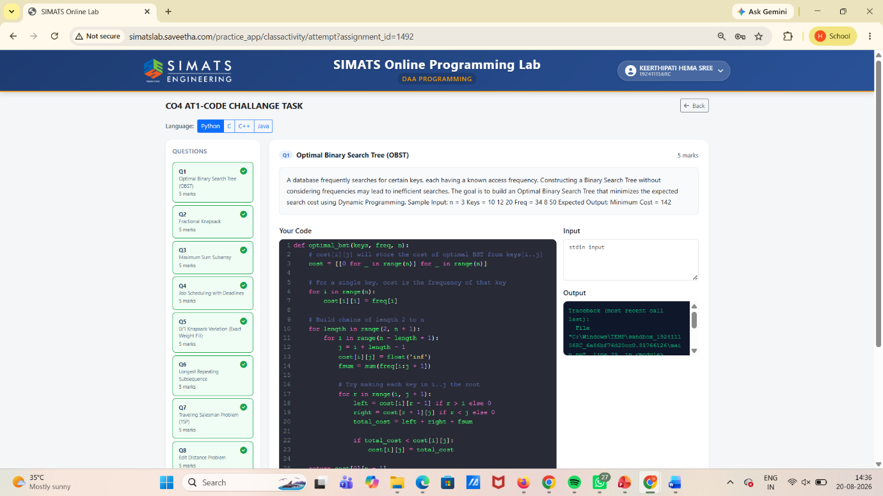

Q2. Fractional Knapsack
Aim:
Maximize total profit when you can take fractions of items.

Algorithm:
- Compute profit/weight ratio for each item.
- Sort items in decreasing order of ratio.
- Take items greedily:
  - If full item fits, take it fully.
  - Else take remaining capacity fraction.
- Sum profit.
Output:
Maximum profit value.
(Example output depends on given input.)
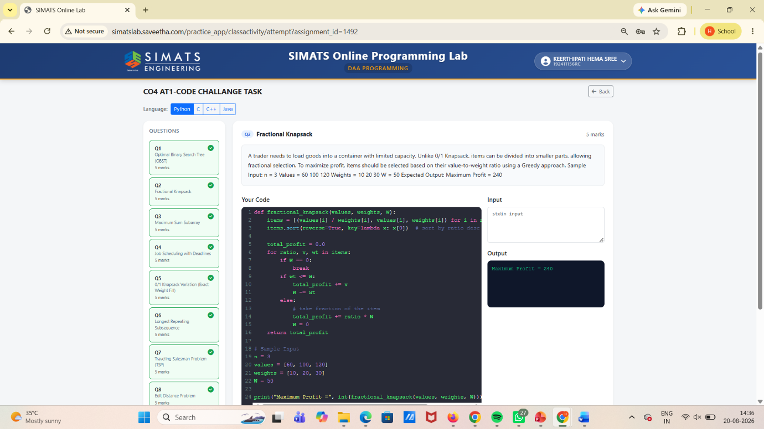

Q3. Maximum Sum Subarray (Kadane’s)
Aim:
Find the subarray with maximum possible sum.

Algorithm:
- Initialize max_so_far = arr[0], curr = arr[0].
- For each element:
  - curr = max(arr[i], curr + arr[i])
  - max_so_far = max(max_so_far, curr)
- Output max_so_far.
Output:
Print maximum subarray sum.
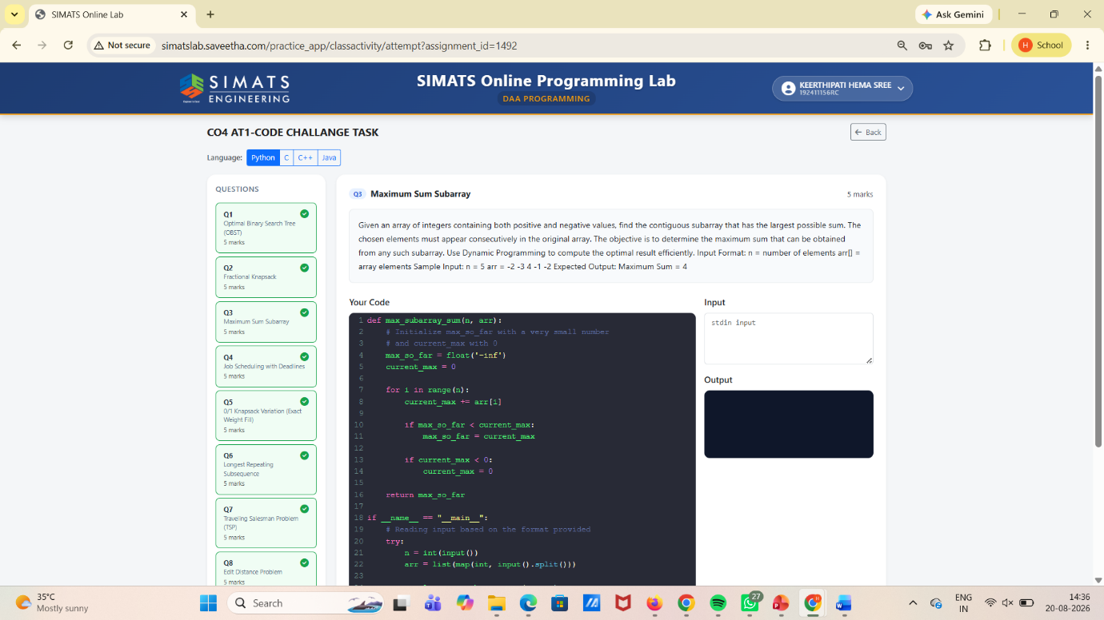

Q4. Job Scheduling with Deadlines
Aim:
Schedule jobs before deadlines to maximize total profit.

Algorithm:
- Sort jobs by decreasing profit.
- Create an array slots of size = maximum deadline.
- For each job:
  - Place it in the latest free slot before its deadline.
- Count selected jobs and total profit.
Output:
Total maximum profit (and scheduled jobs if asked).
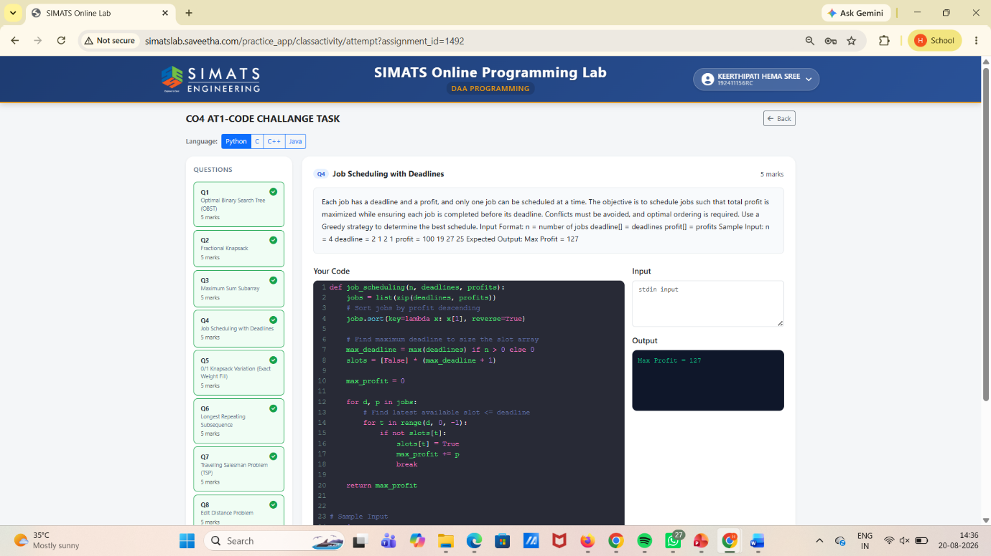

Q5. 0/1 Knapsack Variation (Exact Weight Fill)
Aim:
Fill knapsack to exact weight W using 0/1 items (each item once), maximizing value or checking feasibility.

Algorithm:
- DP array `dp

= best value for exact weight w`.

- Initialize dp[0]=0, others as -inf (unreachable).
- For each item (weight, value):
  - iterate w from W down to weight:
    - dp = max(dp, dp[w-weight] + value)
- Answer = dp[W] (if unreachable, print no solution).

Output:
Best value for exact weight W (or “Not possible”).
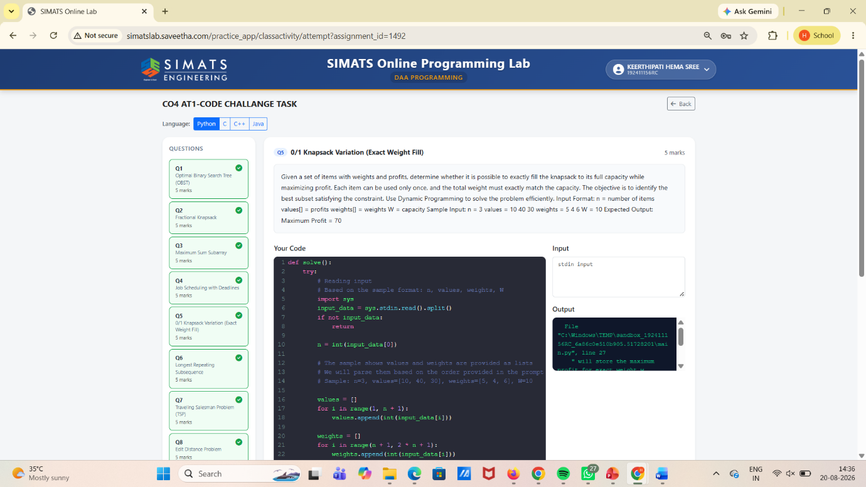

- Q6. Longest Repeating Subsequence
Aim:
Find the longest repeating subsequence in a string.

Algorithm:
- Let s be the string of length n.
- Use DP table dp[i][j].
- If s[i-1] == s[j-1] and i != j:
  - dp[i][j] = 1 + dp[i-1][j-1]
- Else:
  - dp[i][j] = max(dp[i-1][j], dp[i][j-1])
- Answer = dp[n][n].

Output:
Length of longest repeating subsequence.
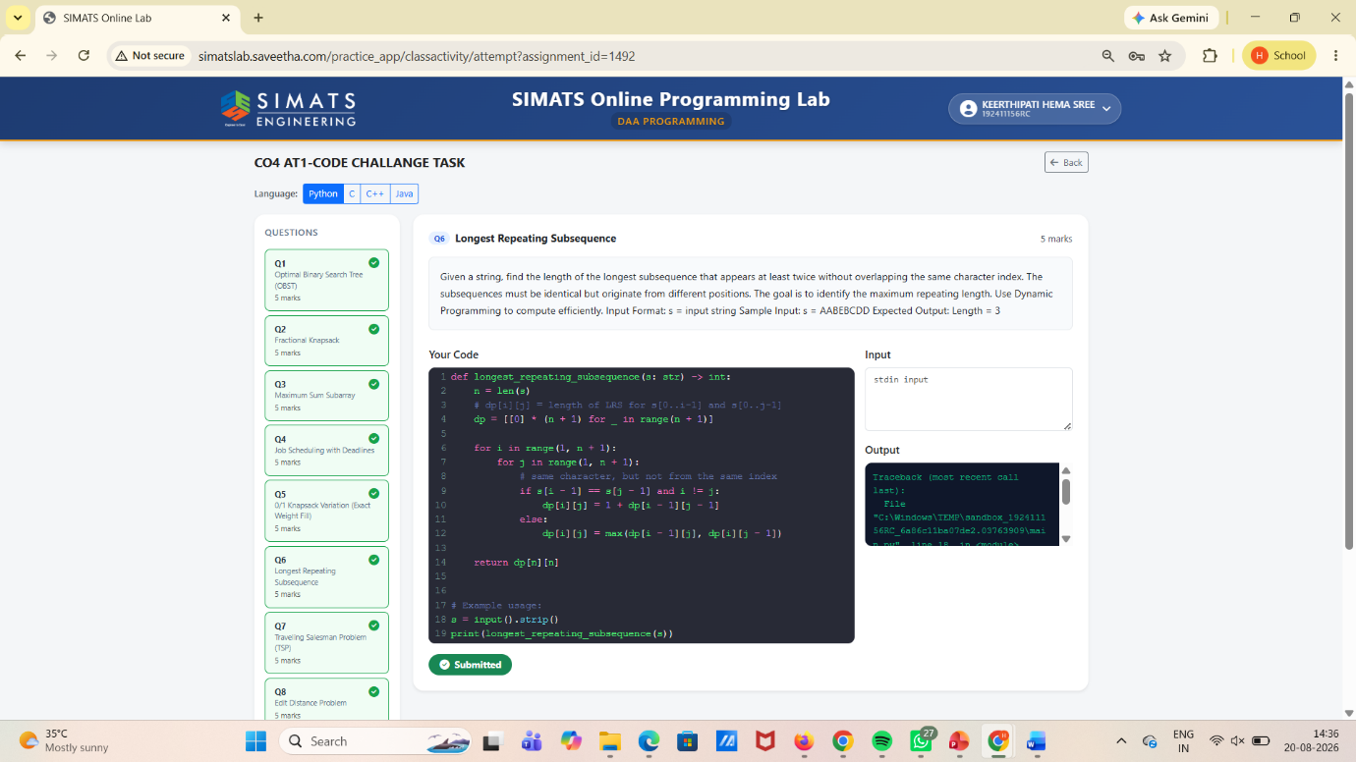

- Q7. Traveling Salesman Problem (TSP)
Aim:
Find the minimum cost Hamiltonian cycle (visit every city exactly once and return).

Algorithm (Typical DP for TSP - Bitmask):
- Use DP: dp[mask][i] = min cost to reach city i having visited set mask.
- Base: dp[1<<start][start] = 0.
- Transition:
  - For each mask, for each i in mask:
    - try next j not in mask:
      - dp[mask | (1<<j)][j] = min(dp[...], dp[mask][i] + cost[i][j])
- Final: add return edge back to start.

Output:
Minimum tour cost.
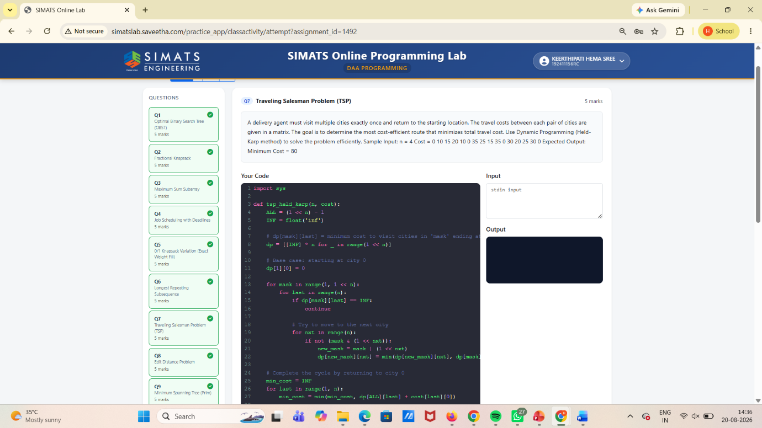

- Q8. Edit Distance Problem
Aim:
Compute minimum operations to convert string A to B:
(insert, delete, replace)

Algorithm:
- Let dp[i][j] = min edits from A[0..i-1] to B[0..j-1].
- Base:
  - dp[i][0] = i (delete all)
  - dp[0][j] = j (insert all)
- If A[i-1] == B[j-1]:
  - dp[i][j] = dp[i-1][j-1]
- Else:
  - dp[i][j] = 1 + min(dp[i-1][j], dp[i][j-1], dp[i-1][j-1])
- Answer = dp[m][n].

Output:
Minimum number of edits.
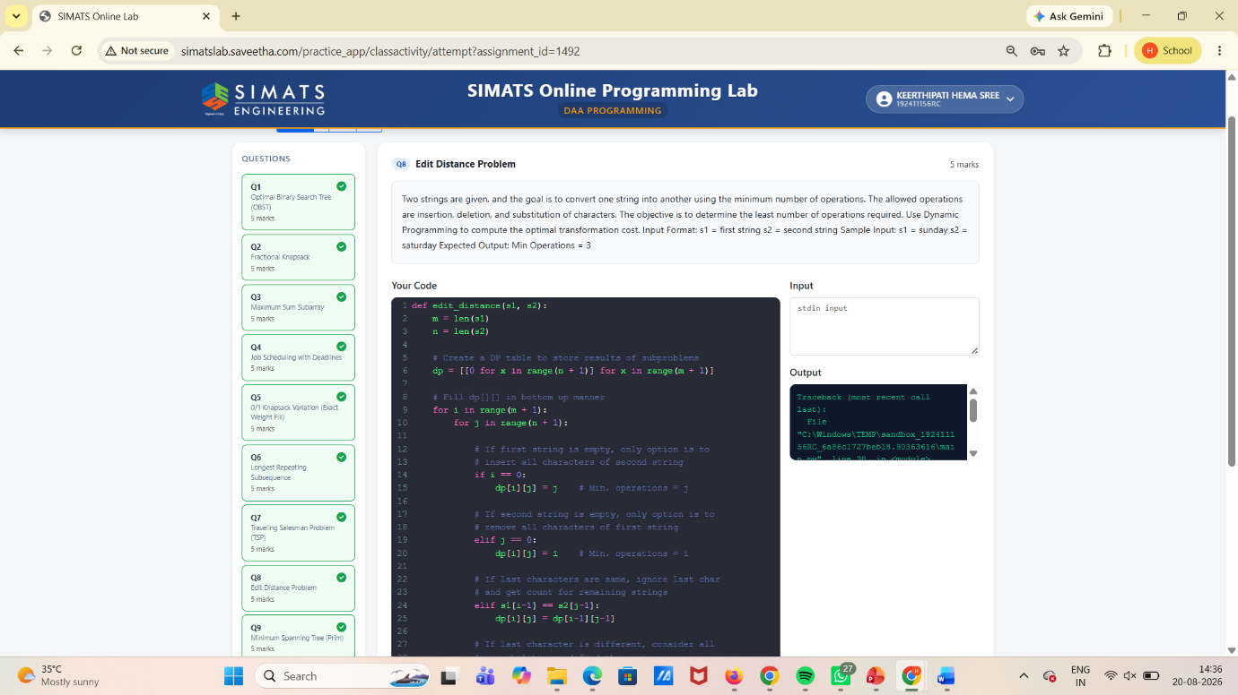

Q9. Minimum Spanning Tree (Prim’s)
Aim:
Find MST with minimum total weight for a connected weighted graph.

Algorithm:
- Start from any node.
- Maintain:
  - key[v] = min edge weight to connect v to MST
  - parent[v] = MST parent
- Repeat:
  - choose vertex u not in MST with smallest key[u]
  - add u to MST
  - update keys of adjacent vertices
- MST edges are from parent[].

Output:
Total MST weight and edges.
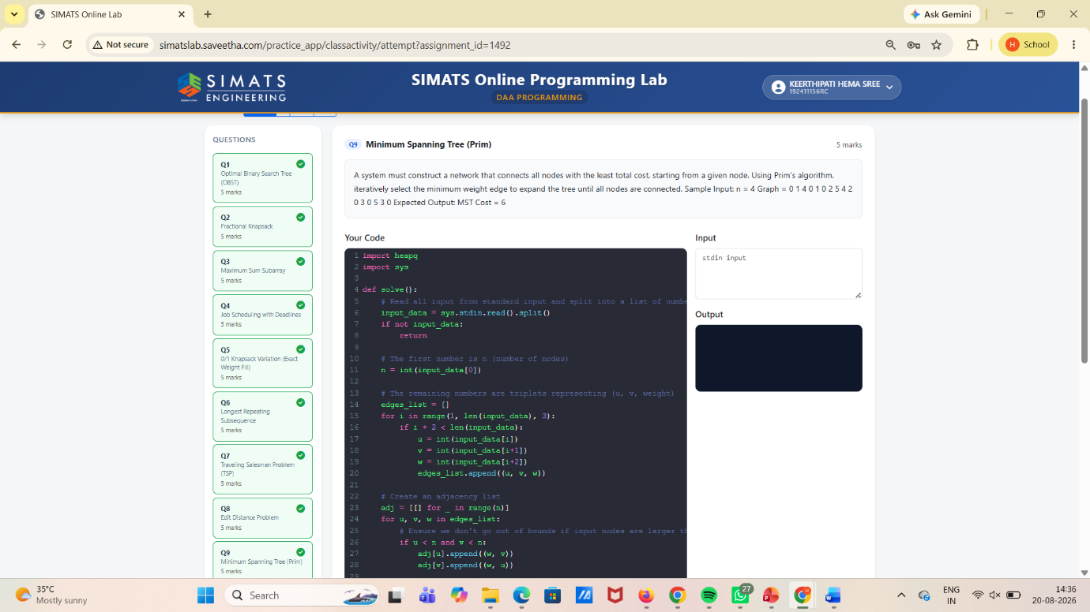

- Q10. Minimum Cost to Merge Stones
Aim:
Merge stones into one pile with minimum total cost.
Cost of merging a range = sum of stones in that range.

Algorithm (DP with Prefix Sum):
- Precompute prefix sums prefix[] so range sum is fast.
- dp[i][j] = minimum cost to merge stones from i to j.
- Length from 2 to n:
  - dp[i][j] = min(dp[i][k] + dp[k+1][j] + sum(i..j))
- Answer = dp[0][n-1].

Output:
Minimum cost to merge all stones.
